**Unit - 2**

1. WAP that prints the address of 'www.tufohss.edu.np'.

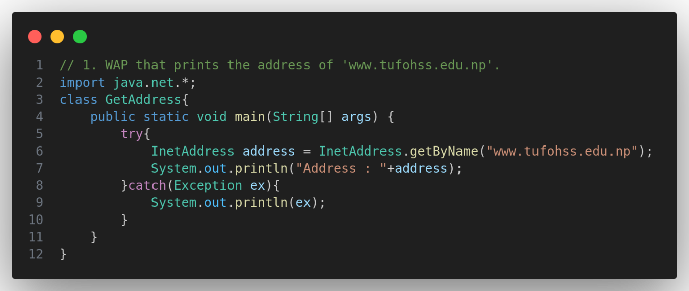

1. WAP that finds the address of local machine.

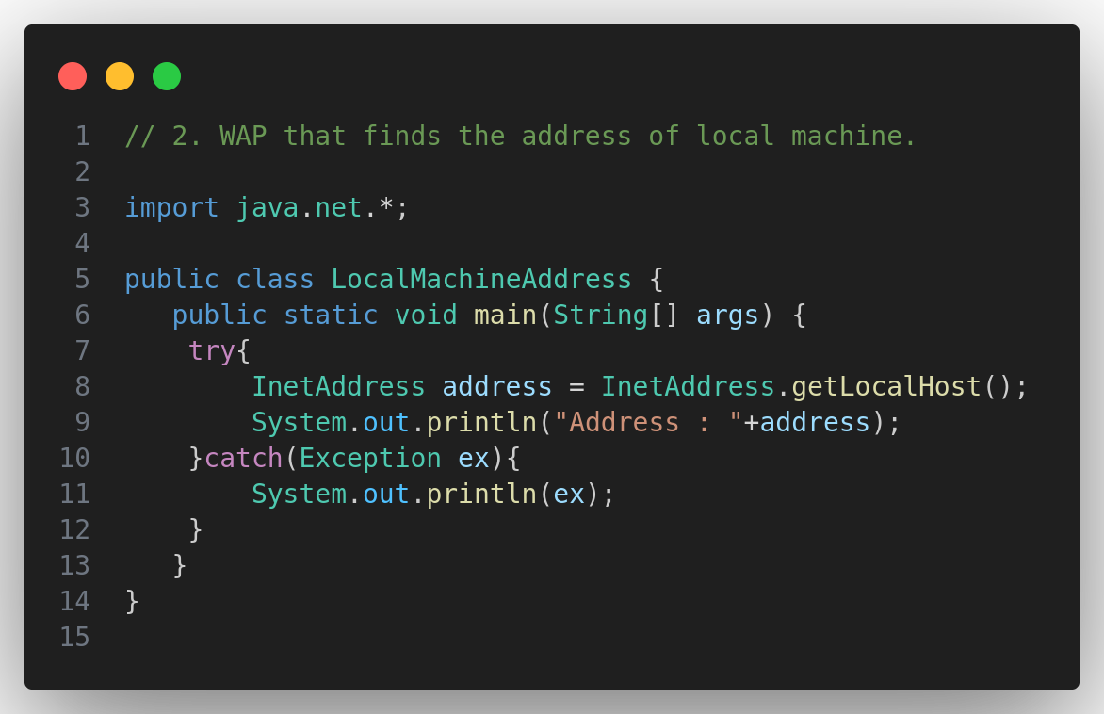

1. WAP that find the canonical host name of the given address.

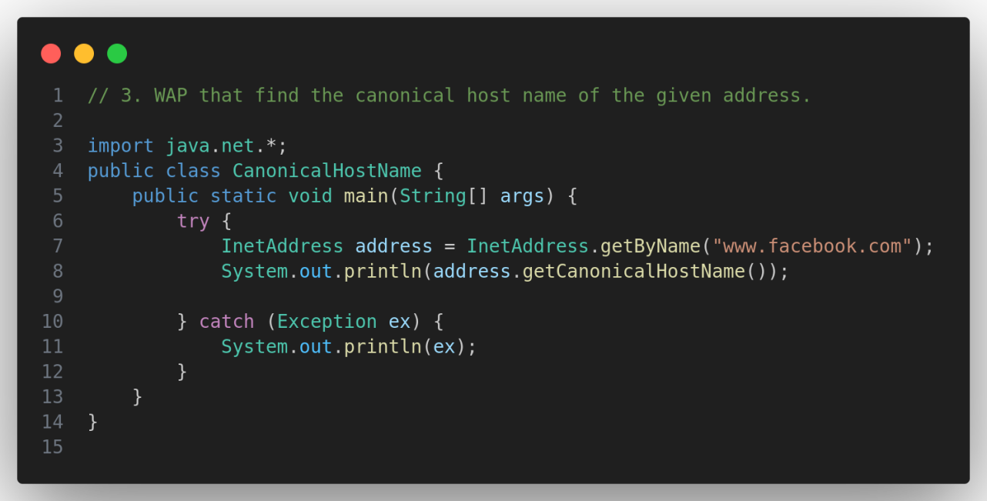

1. WAP to find the IP Address and Host Name of a local machine.

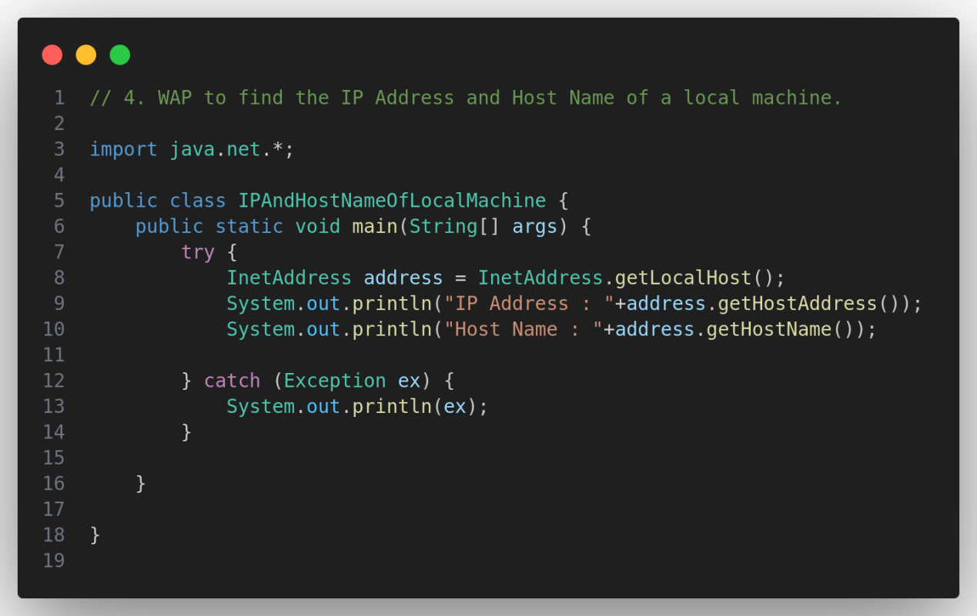

1. WAP to get IP Address of IPV4 & IPV6 of a given Web Address.

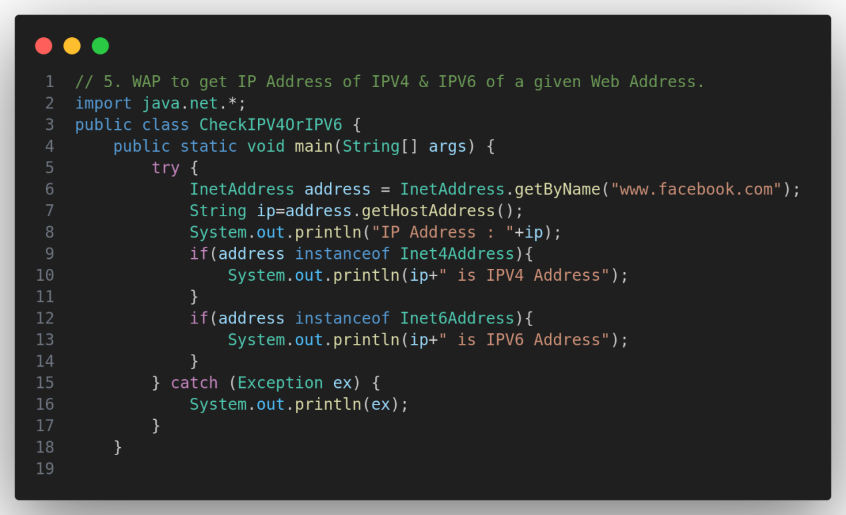

1. WAP for determining whether an IP Address is IPV4 or IPV6.

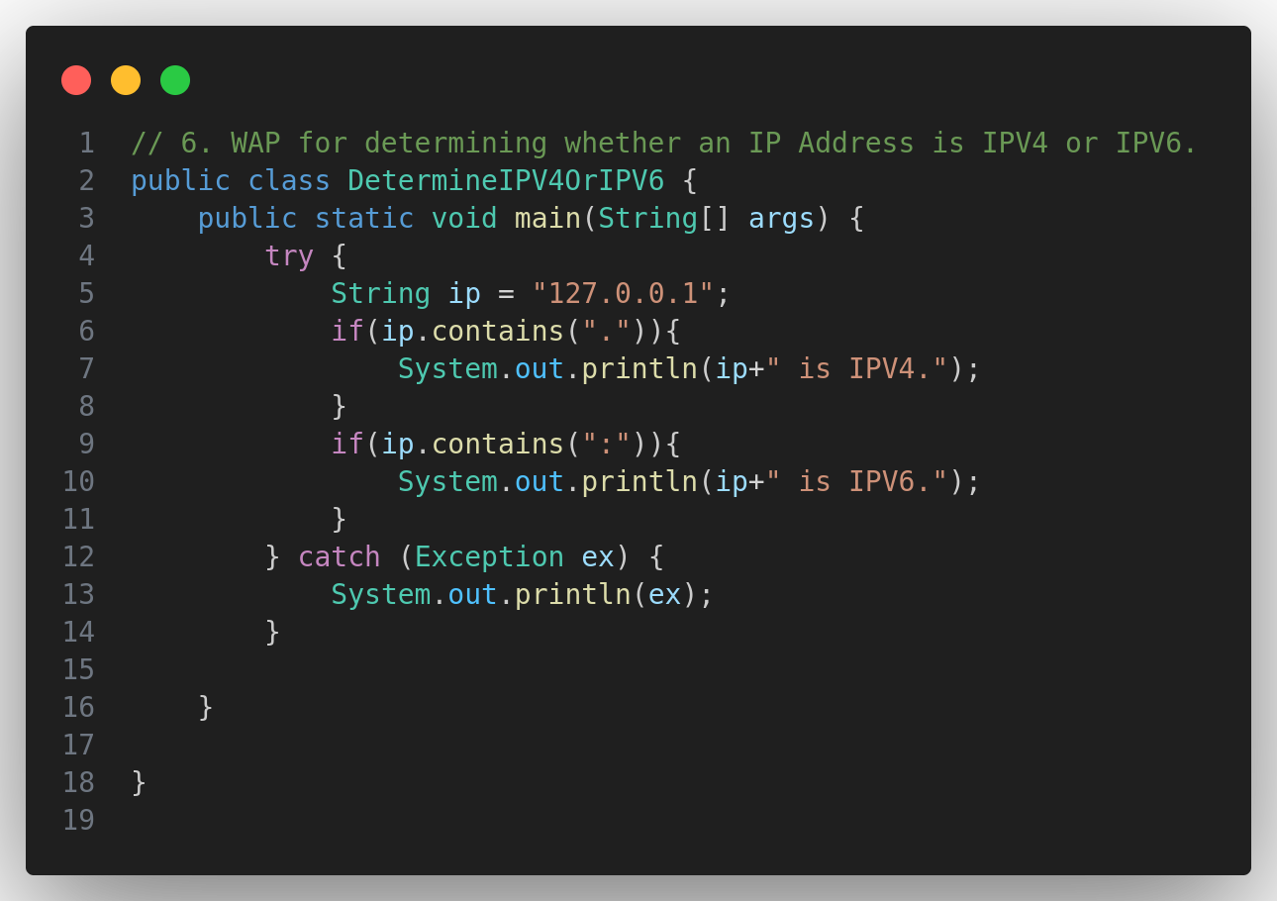

1. WAP for testing the Characteristics of an IP Address.

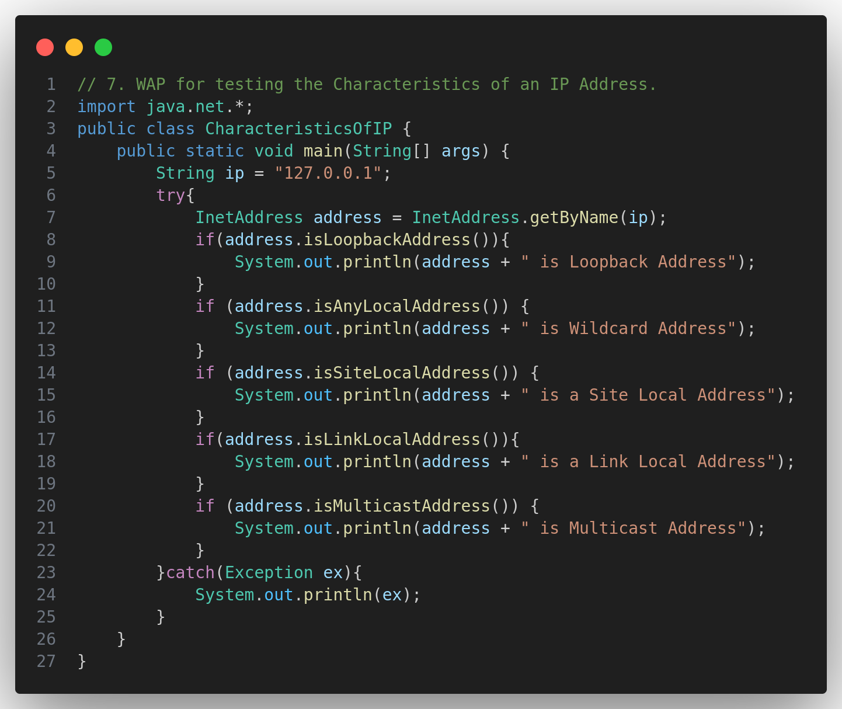

1. WAP that compares the domain names 'www.ibiblio.org' and 'helios.ibiblio.org'.

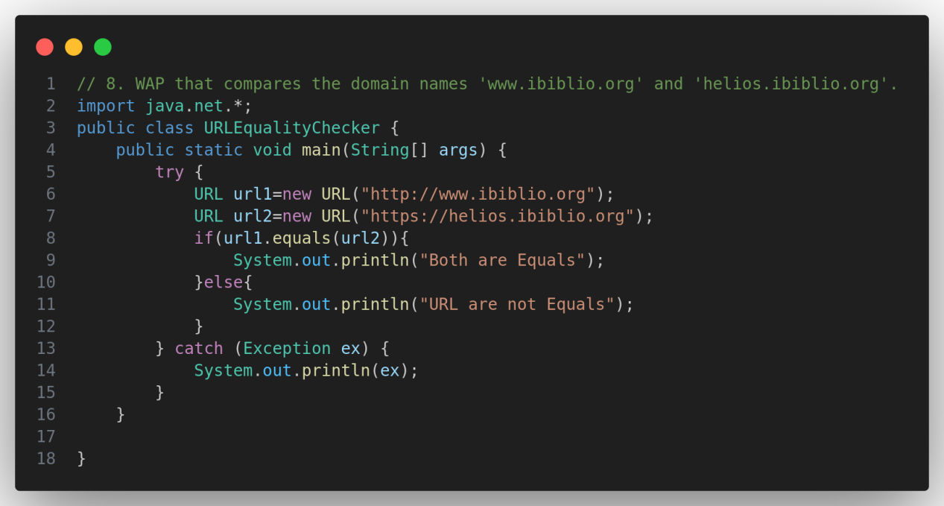

1. WAP that list all the network interface.

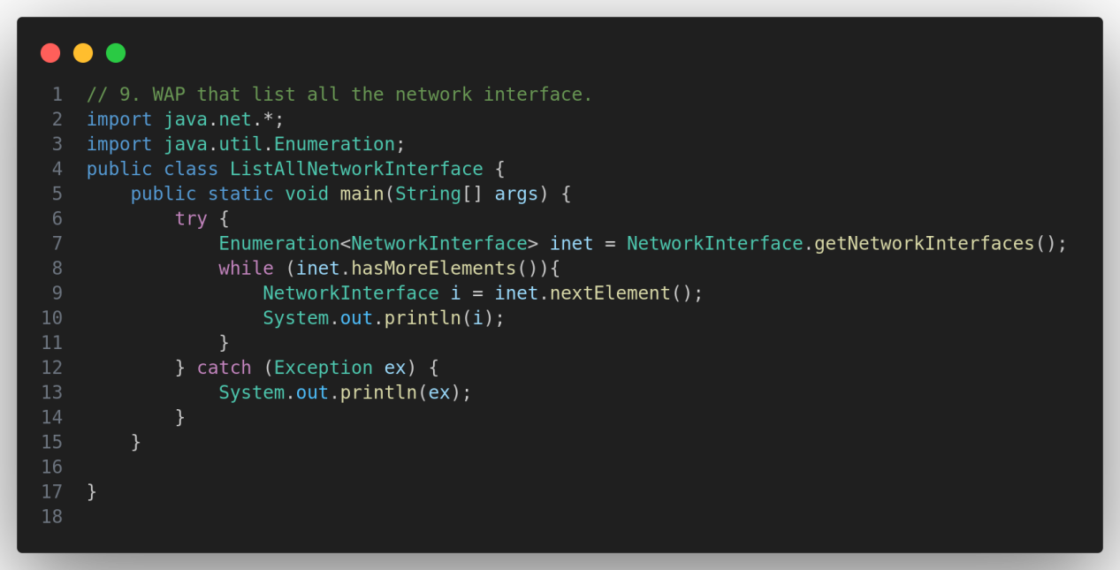

1. WAP to use of Network Interface using getter method.

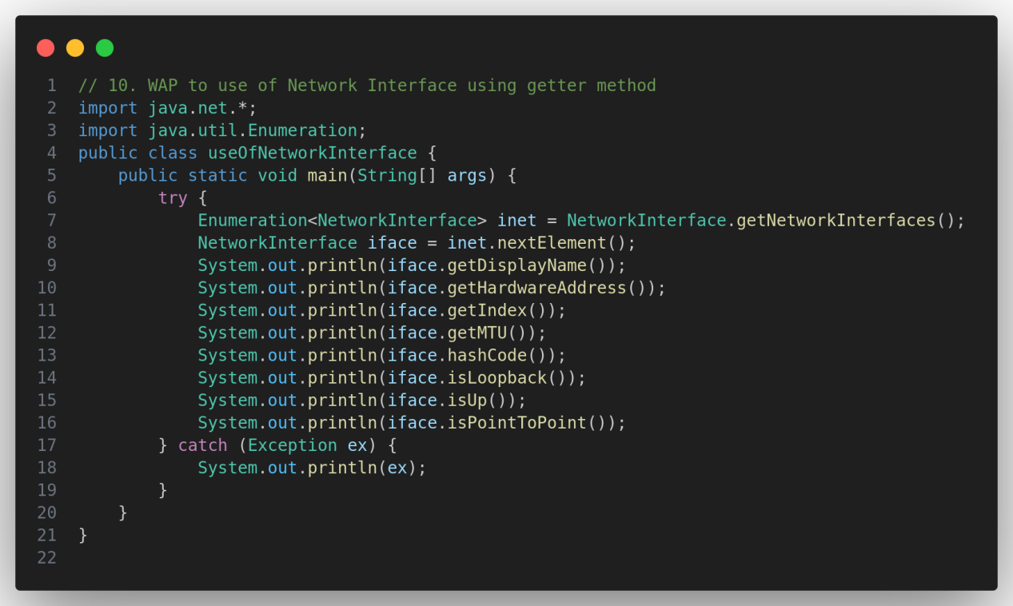

1. WAP to check remote system is reachable or not.

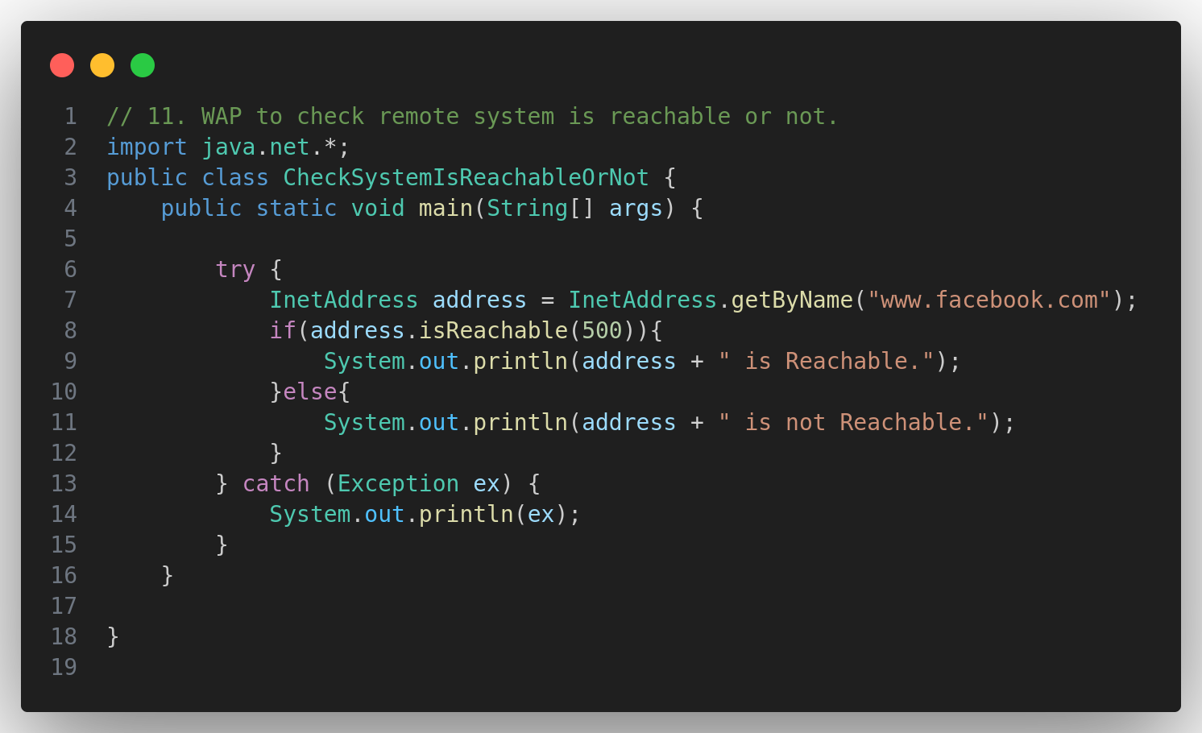

1. WAP that demonstrate the Spam Check.

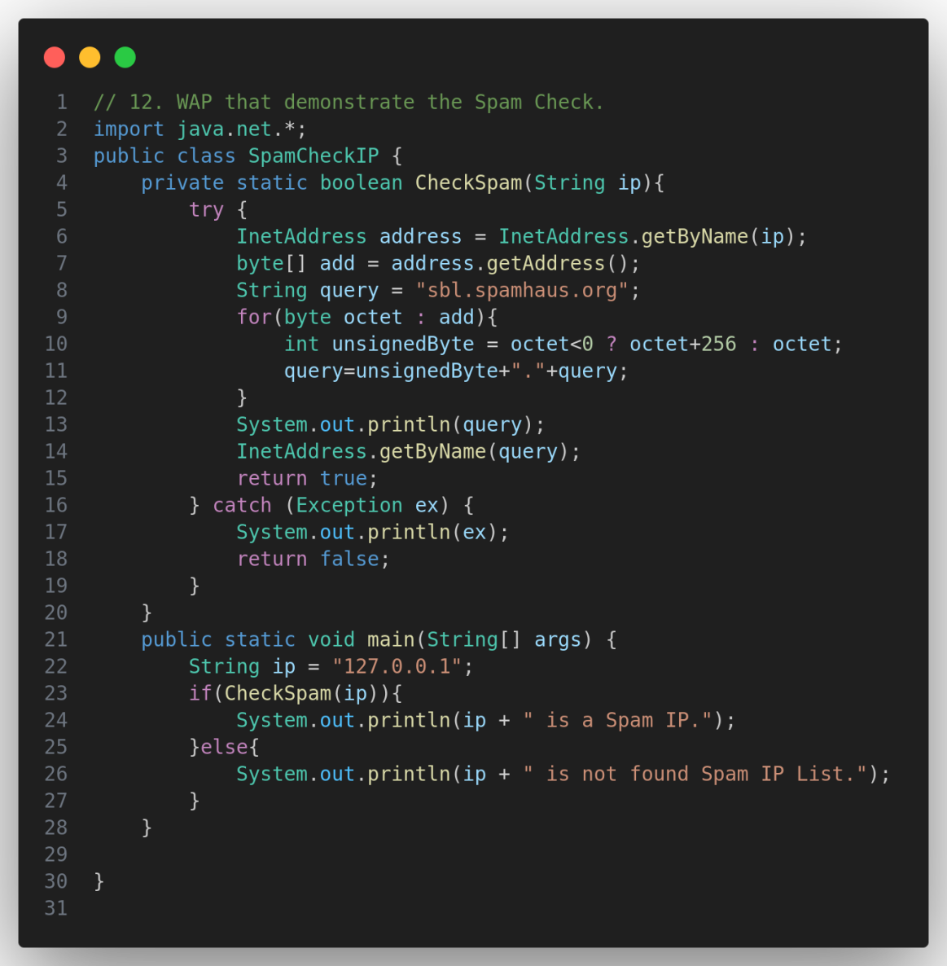

1. WAP to process Web Server log file.

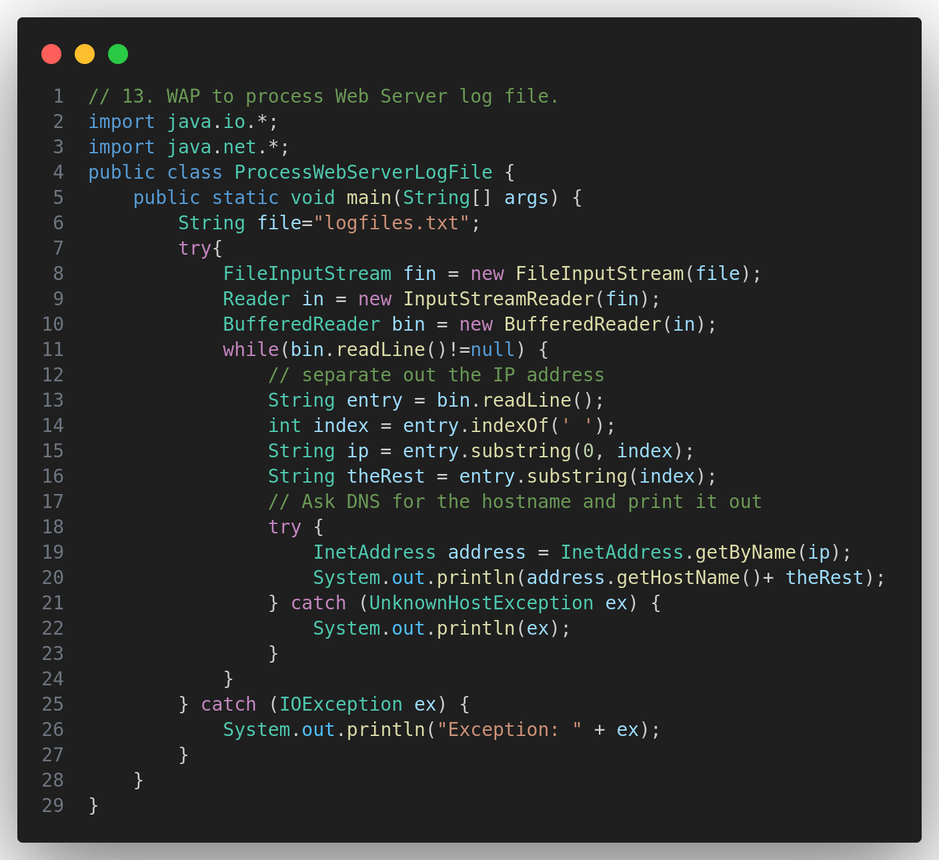

**Unit - 3**

1. WAP that split the part of URL.

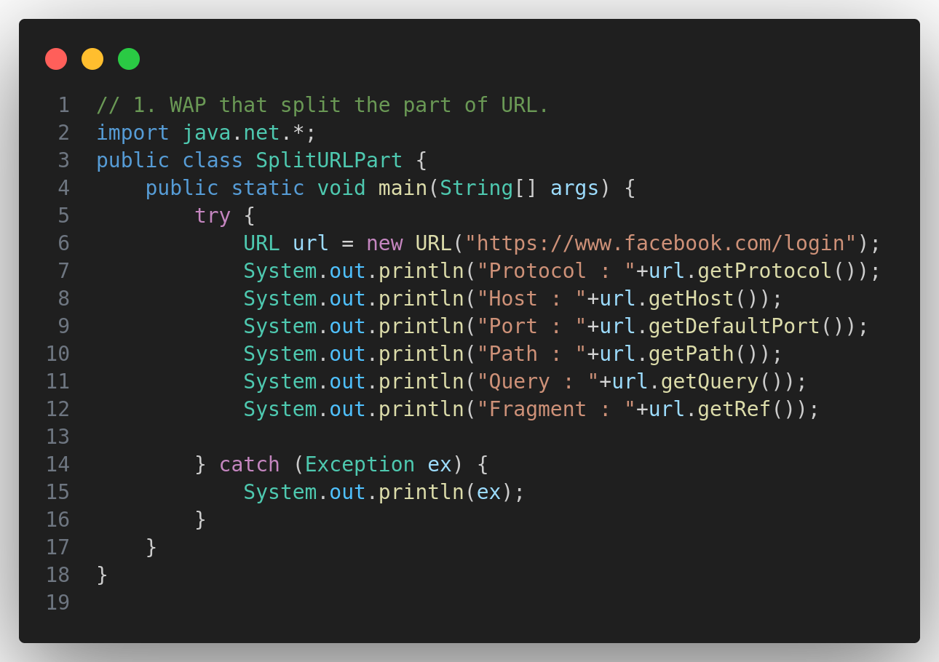

1. WAP that check which protocol does a virtual machine support or not.

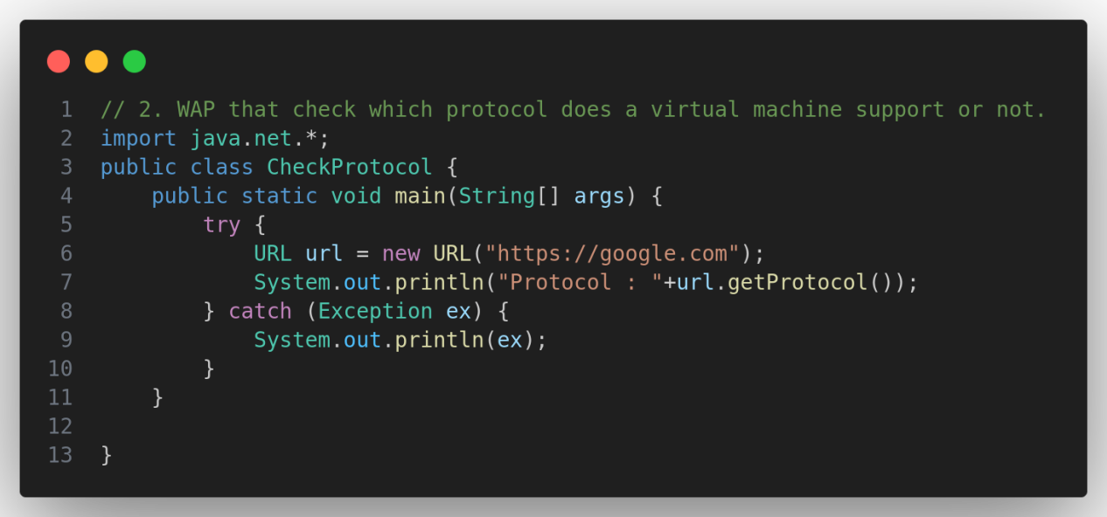

1. WAP to download a webpage of a given web address.

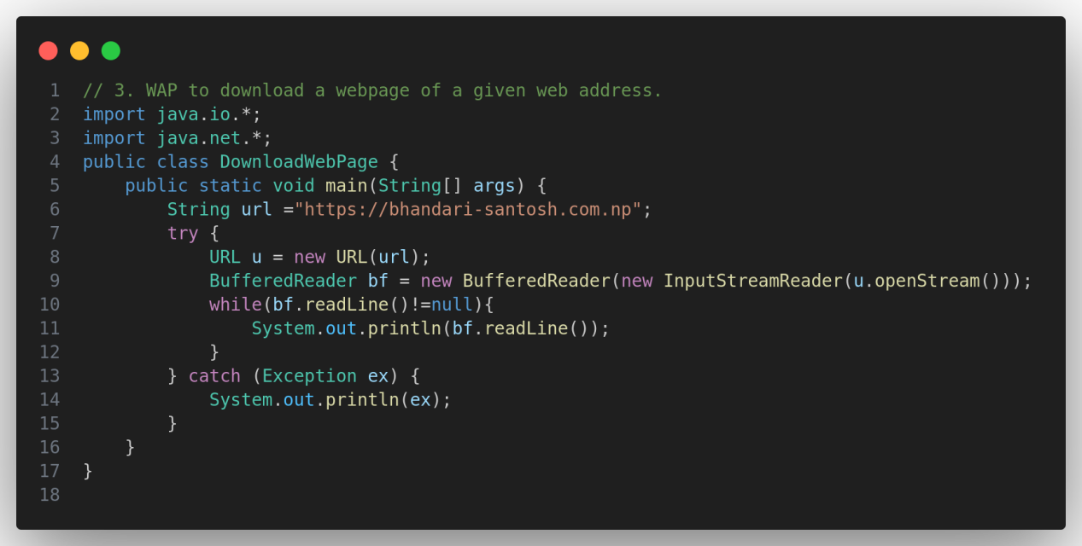

1. WAP to download an objects.

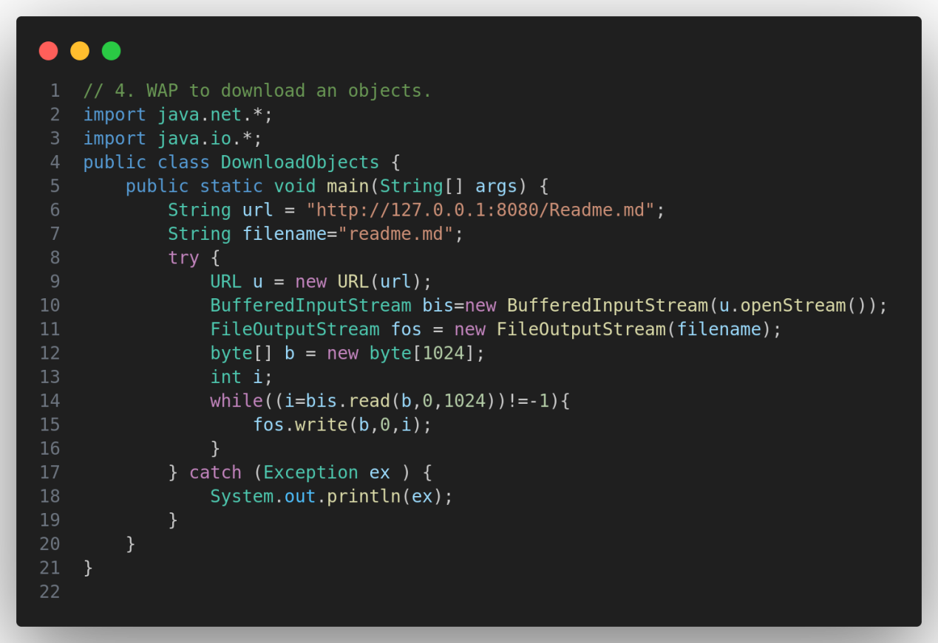

1. WAP to demonstrate x-www-form-urlencoded String.

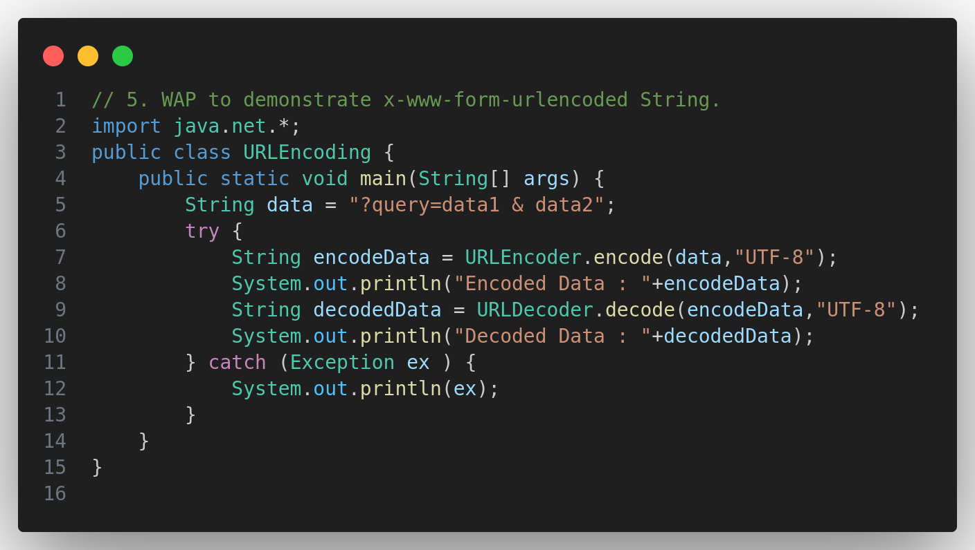

1. WAP to communicate with server side program through get.

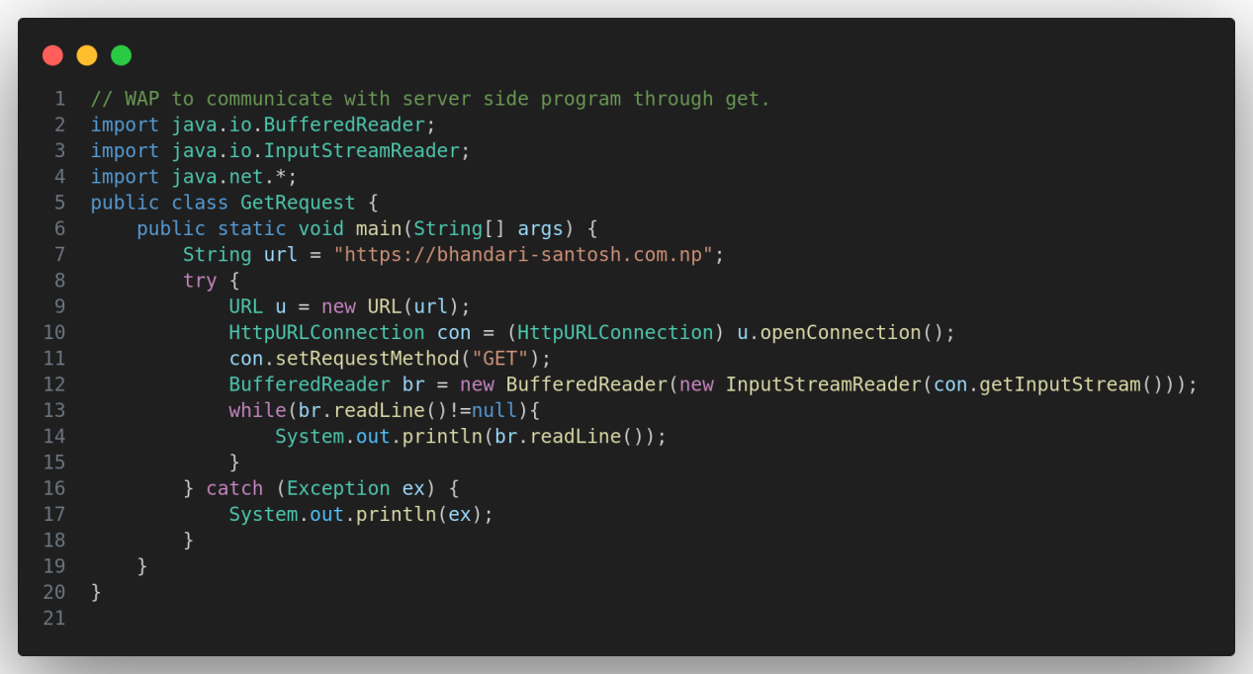

1. WAP to resolve relative URI.

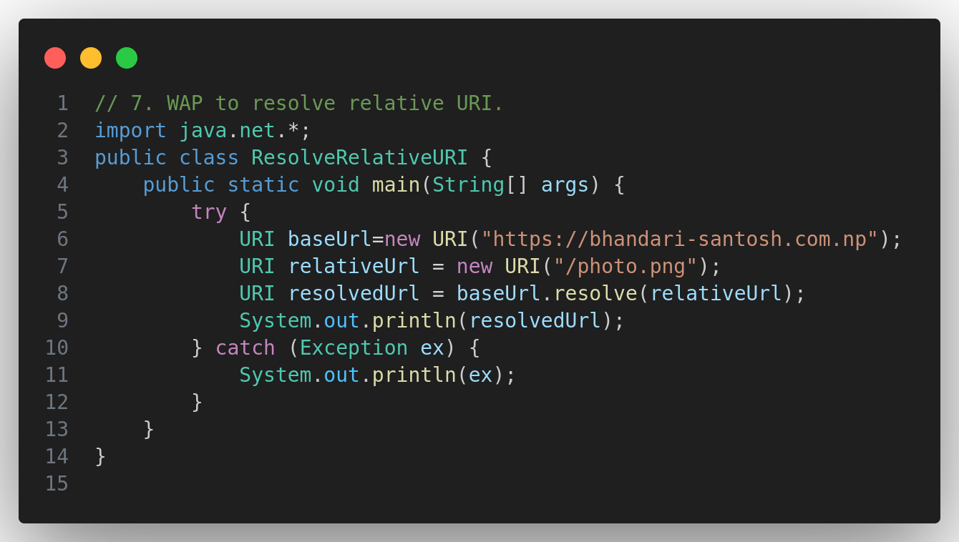

**Unit - 5**

1. WAP to download a Webpage using URL Connection.

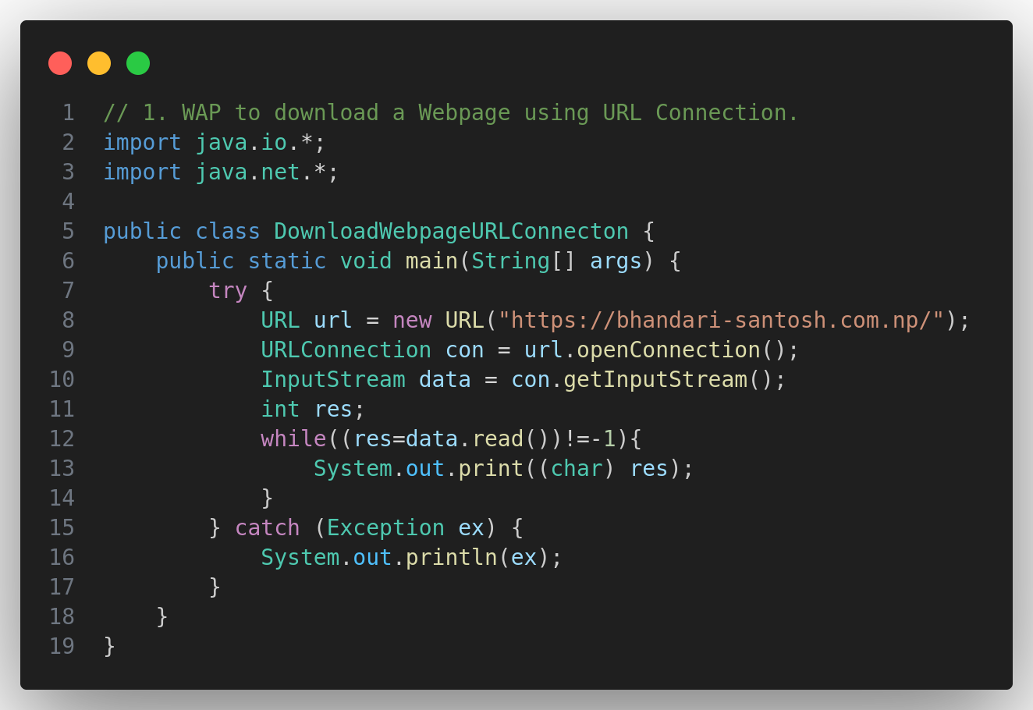

1. WAP to read the Value of HTTP Header Fields.

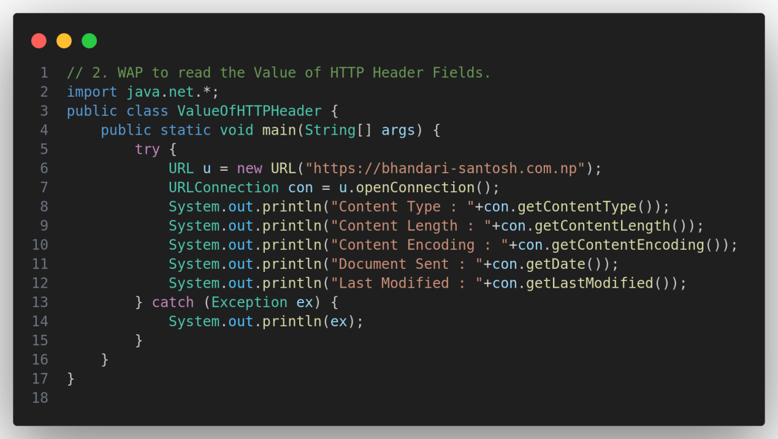

1. WAP to print entire HTTP Headers.

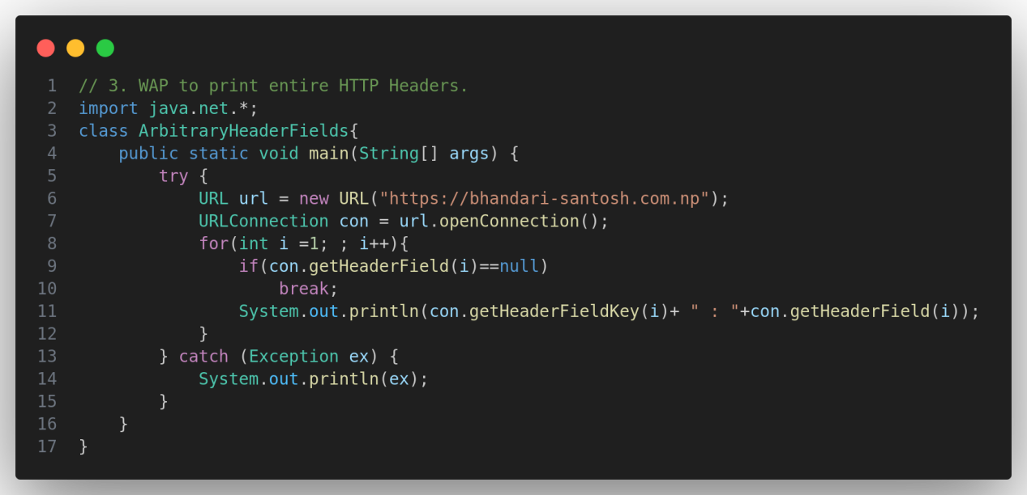

1. WAP for HTTP request Method. - Not Done
2. WAP to print URL of a URL Connection to "tufohss.edu.np".

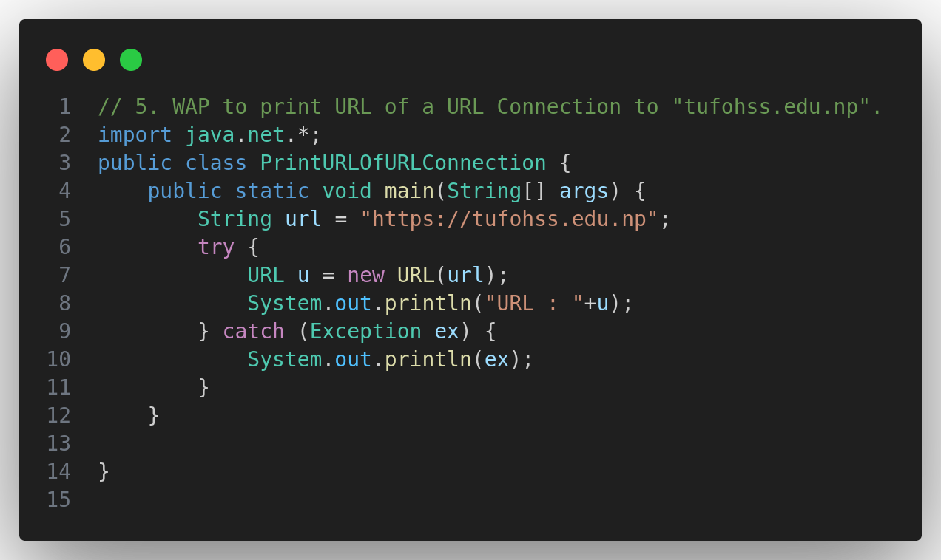

1. WAP to get a time when a URI was last change.

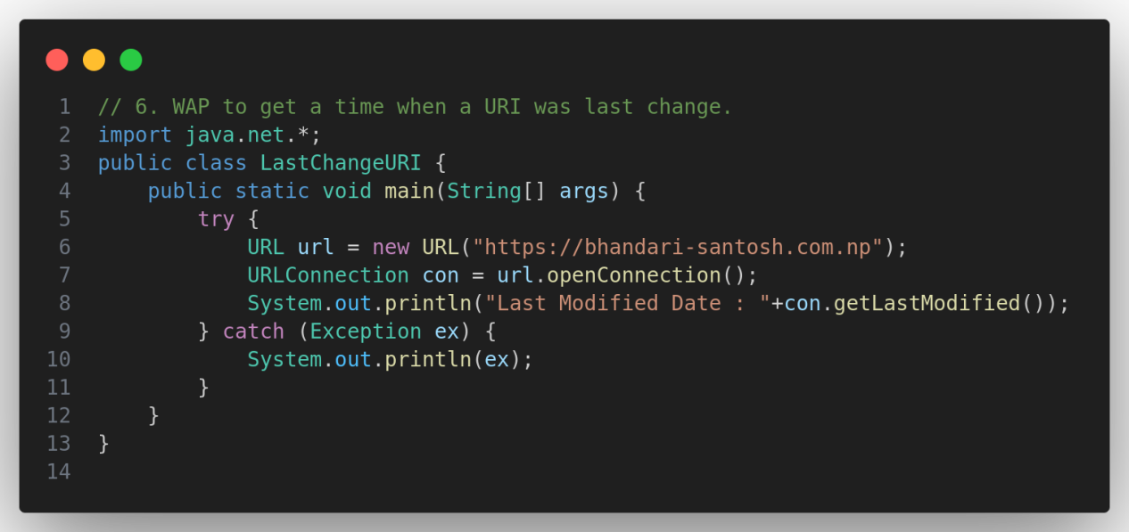

**Unit - 6**

1. WAP of Socket to Client.

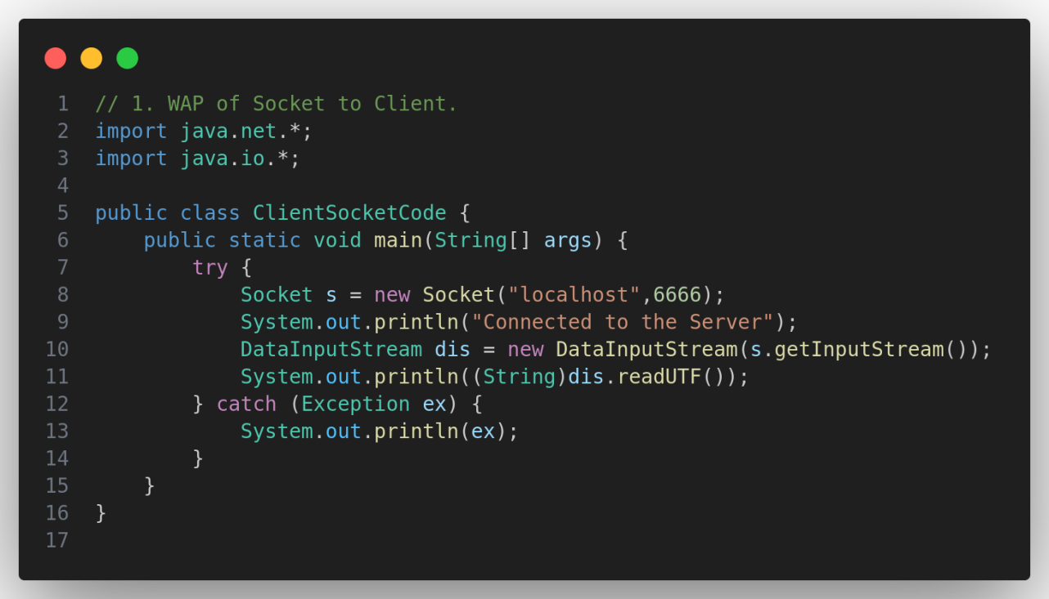

**Unit - 7**

1. WAP of Socket for Server.

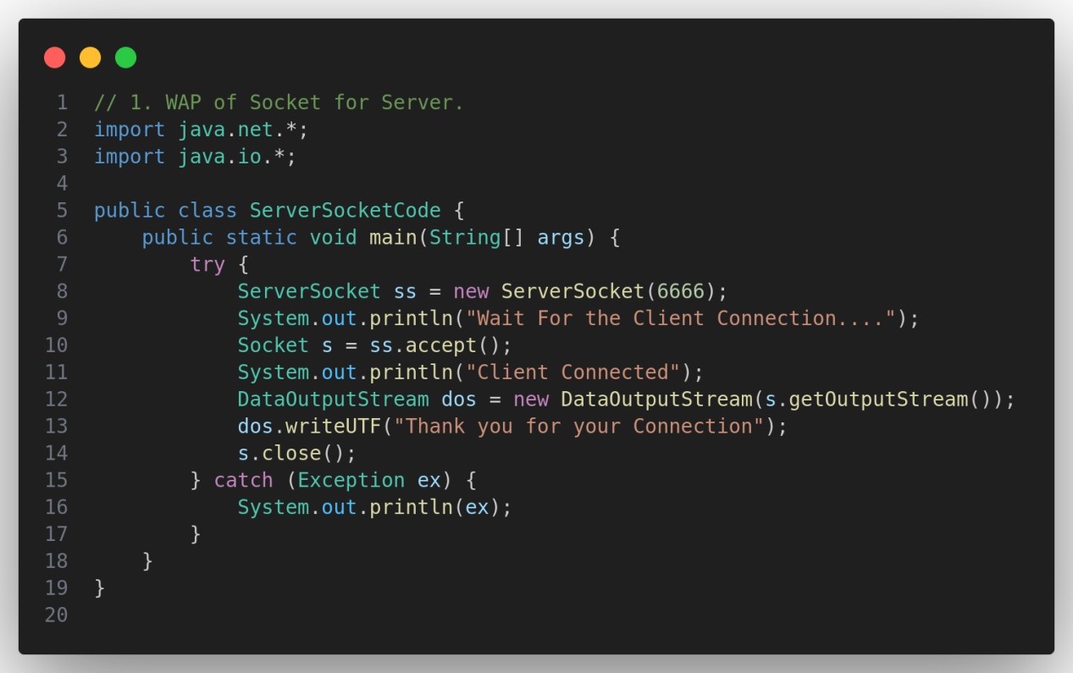

**Client Server Communication**

